Fresh Trace

APPENDIX A (DESIGN DOCUMENTS)
Submitted by:
Team 5:
Sinikiem Azaiki
Burak Koseoglu
Rexy Sara Raju
Krish Mukesh Singh
Ba Thinh Vuong
Amirhossein Mohammadi

Submitted to: Nesovic, Jake
ICET Department,
School of Engineering Technology and Applied Science
Progress Campus, Block A
Centennial College
Discipline: Software Engineering

Table of Figures
Fig 1: System Architecture Diagram 2
Fig 2: Use Case Diagram 3
Fig 3: Class Diagram 4
Fig 4: Object Diagram 1(Inventory state change) 5
Fig 5: Object Diagram 2(Food expiry notification) 5
Fig 6: Object Diagram 3 (Grocery tracking system) 6
Fig 7: Component Diagram 6
Fig 8: Deployment Diagram 7
Fig 9: Activity Diagram (Users Food list) 8
Fig 10: Activity Diagram (Users Scan Receipt) 9
Fig 11: Activity Diagram (Analytics and Error logs) 10
Fig 12: Activity Diagram (Admin Users List) 11
Fig 13: Sequence Diagram (User dashboard) 12
Fig 14: Sequence Diagram (User food list) 13
Fig 15: Sequence Diagram (User scan receipt) 14
Fig 16: Sequence Diagram (Admin analytics) 15
Fig 17: Sequence Diagram (Admin error logs) 16
Fig 18: Sequence Diagram (Admin users list) 17
Fig 19: ERD Diagram 18
Fig 20: Paper Prototype 1 19
Fig 21: Paper Prototype 2 20
Fig 22: Paper Prototype 3 20
Fig 23: Paper Prototype 4 21
Fig 24: Paper Prototype 5 22
Fig 25: Paper Prototype 6 23
Fig 26: Paper Prototype 7 24
Fig 27: Paper Prototype 8 25
Fig 28: Paper Prototype 9 26
Fig 29: Paper Prototype 10 27
Fig 30: Paper Prototype 11 27

A1. System Architecture Diagram (Developer’s perspective):
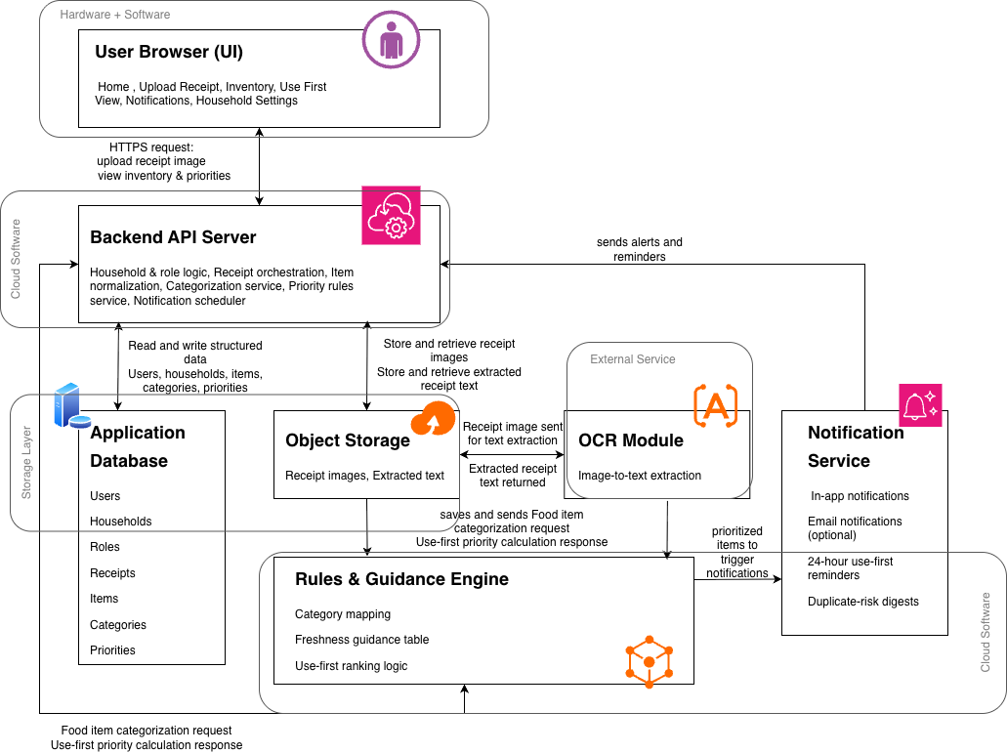
Fig 1: System Architecture Diagram

A2. Use Case Diagram
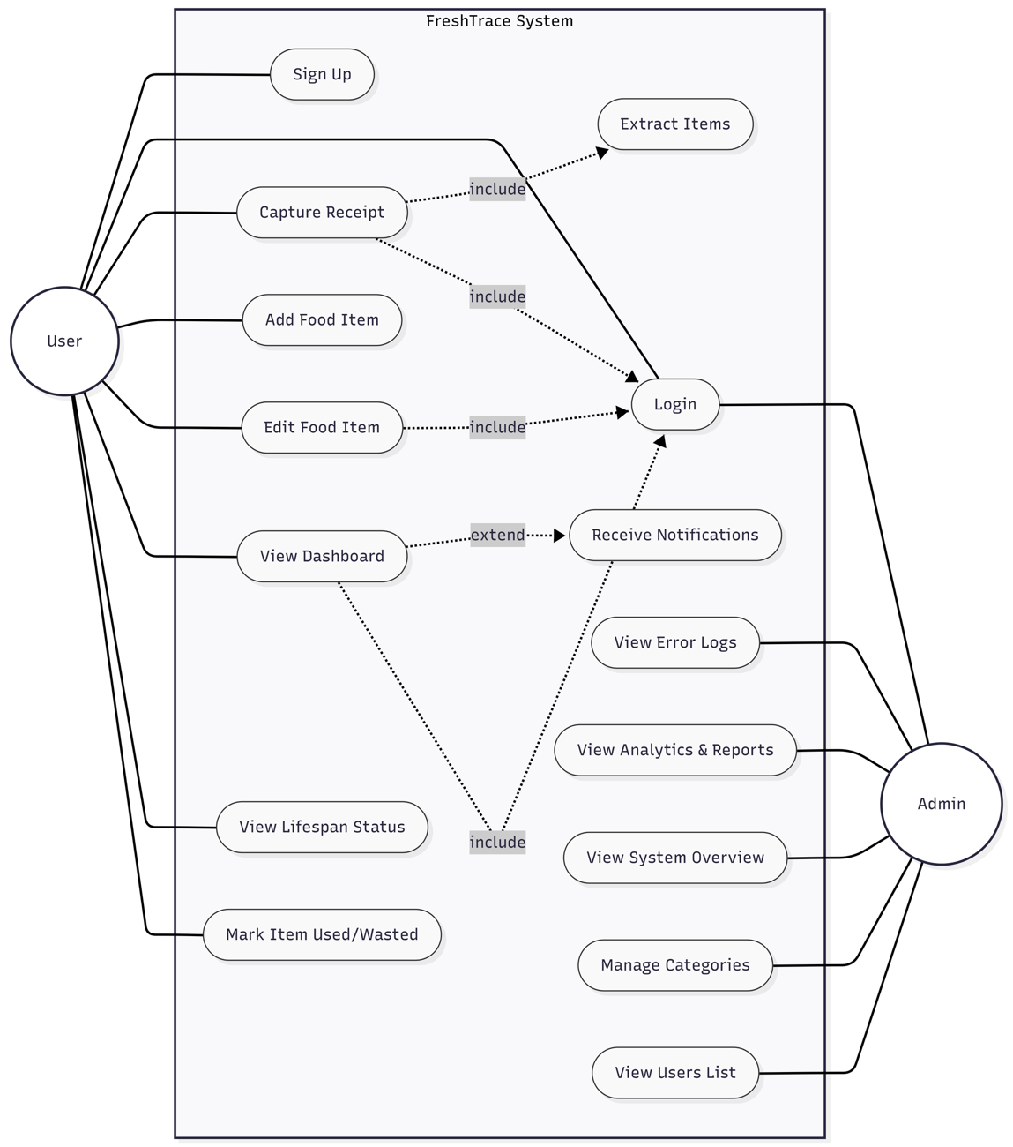
Fig 2: Use Case Diagram

A3. Class Diagram
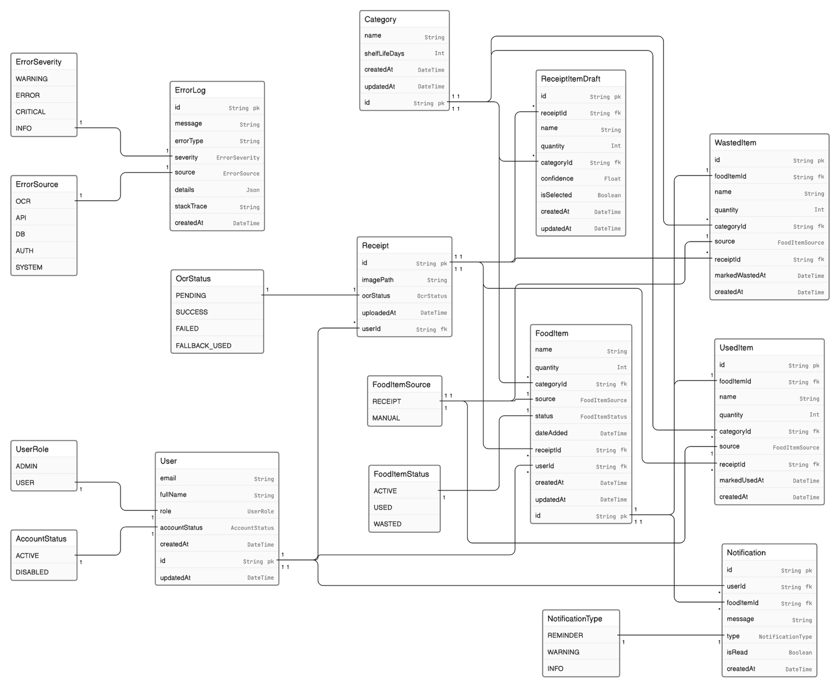
Fig 3: Class Diagram

A4. Object Diagram
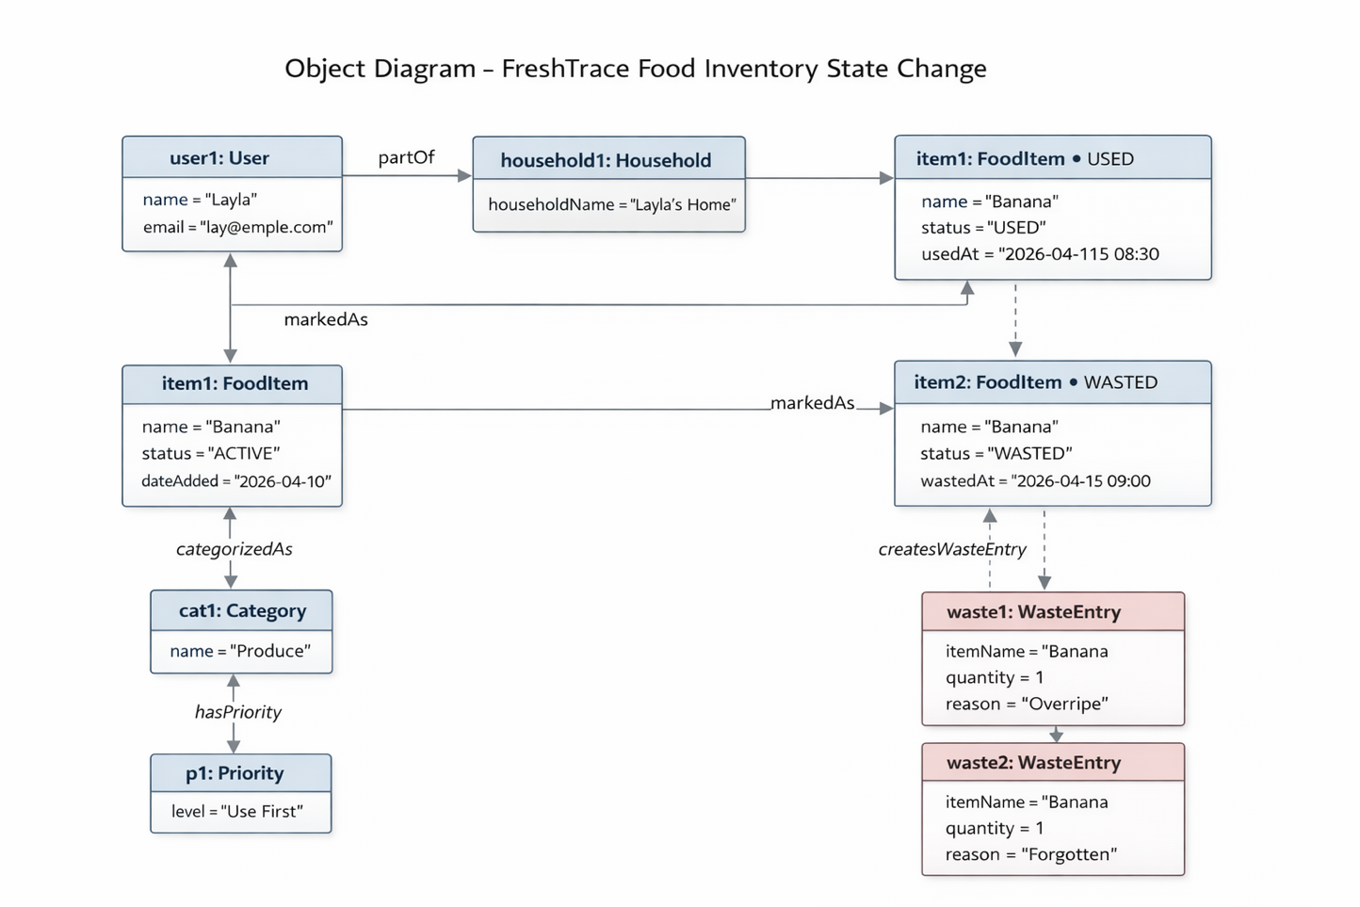
Fig 4: Object Diagram 1(Inventory state change)
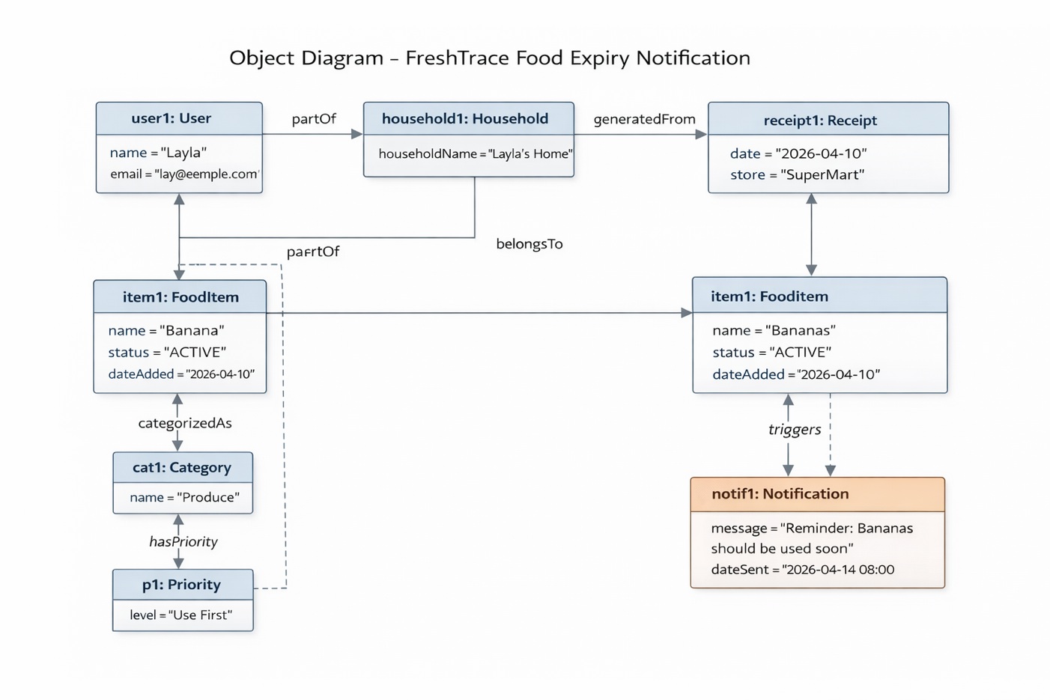
Fig 5: Object Diagram 2(Food expiry notification)
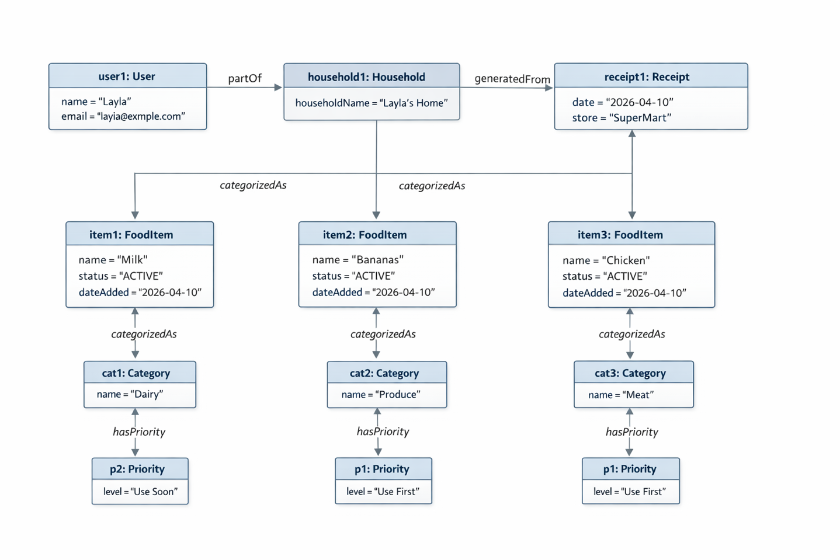
Fig 6: Object Diagram 3 (Grocery tracking system)

A5. Component Diagram
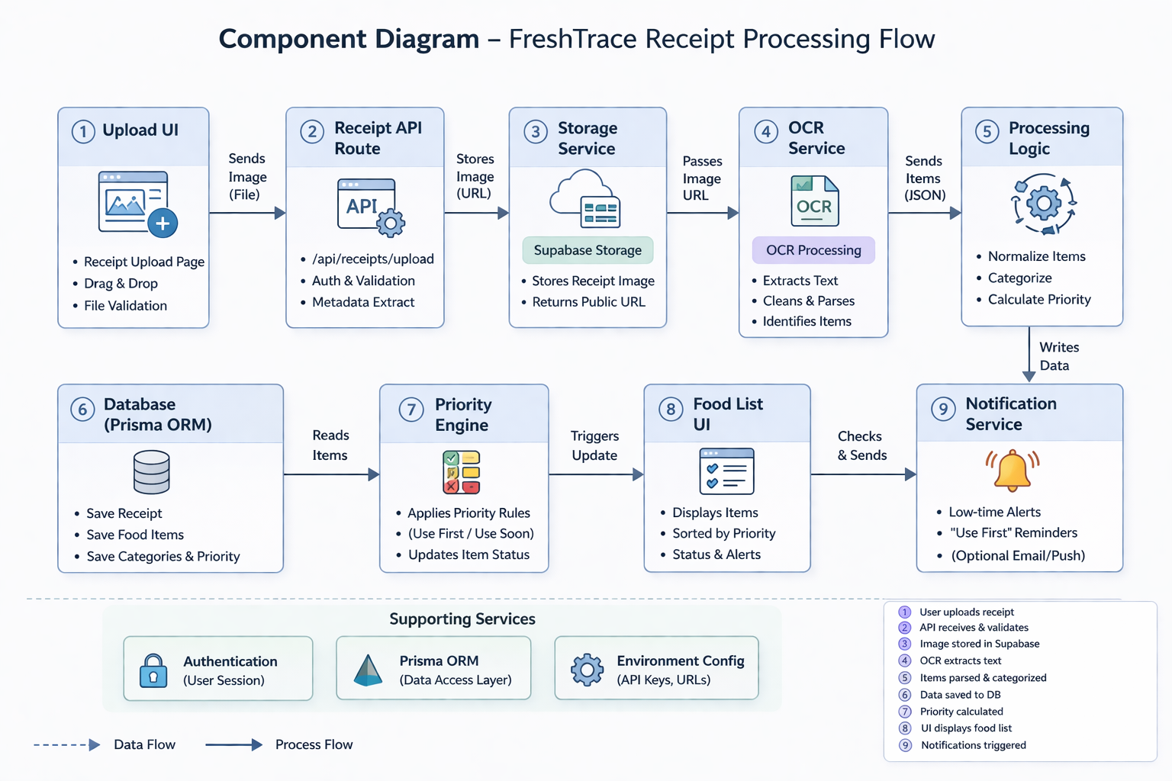
Fig 7: Component Diagram

A6. Deployment Diagram
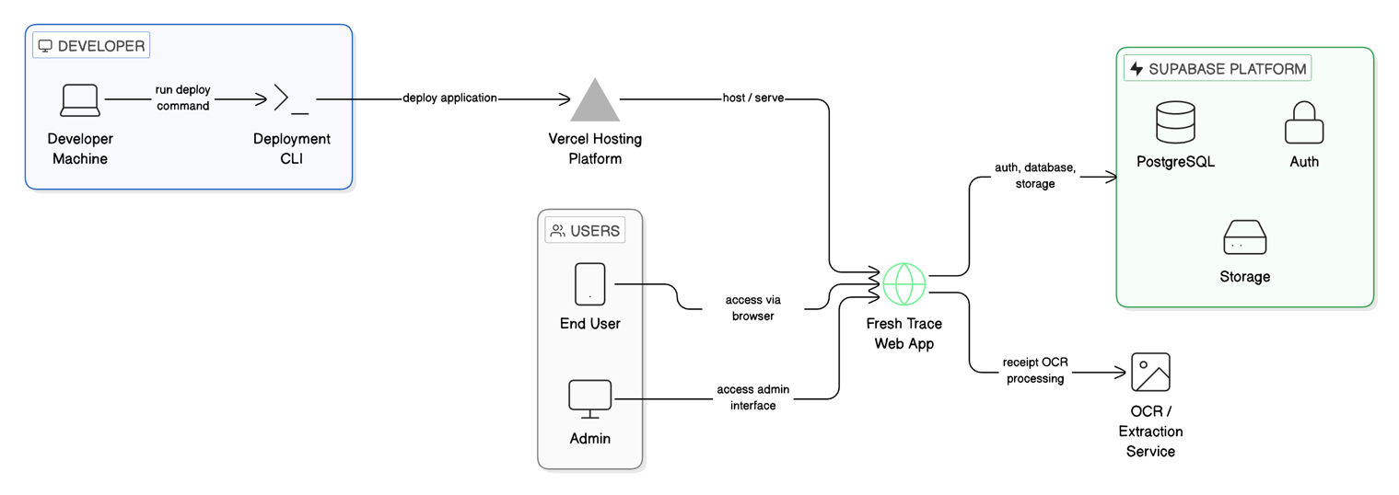
Fig 8: Deployment Diagram

A7. Activity Diagram

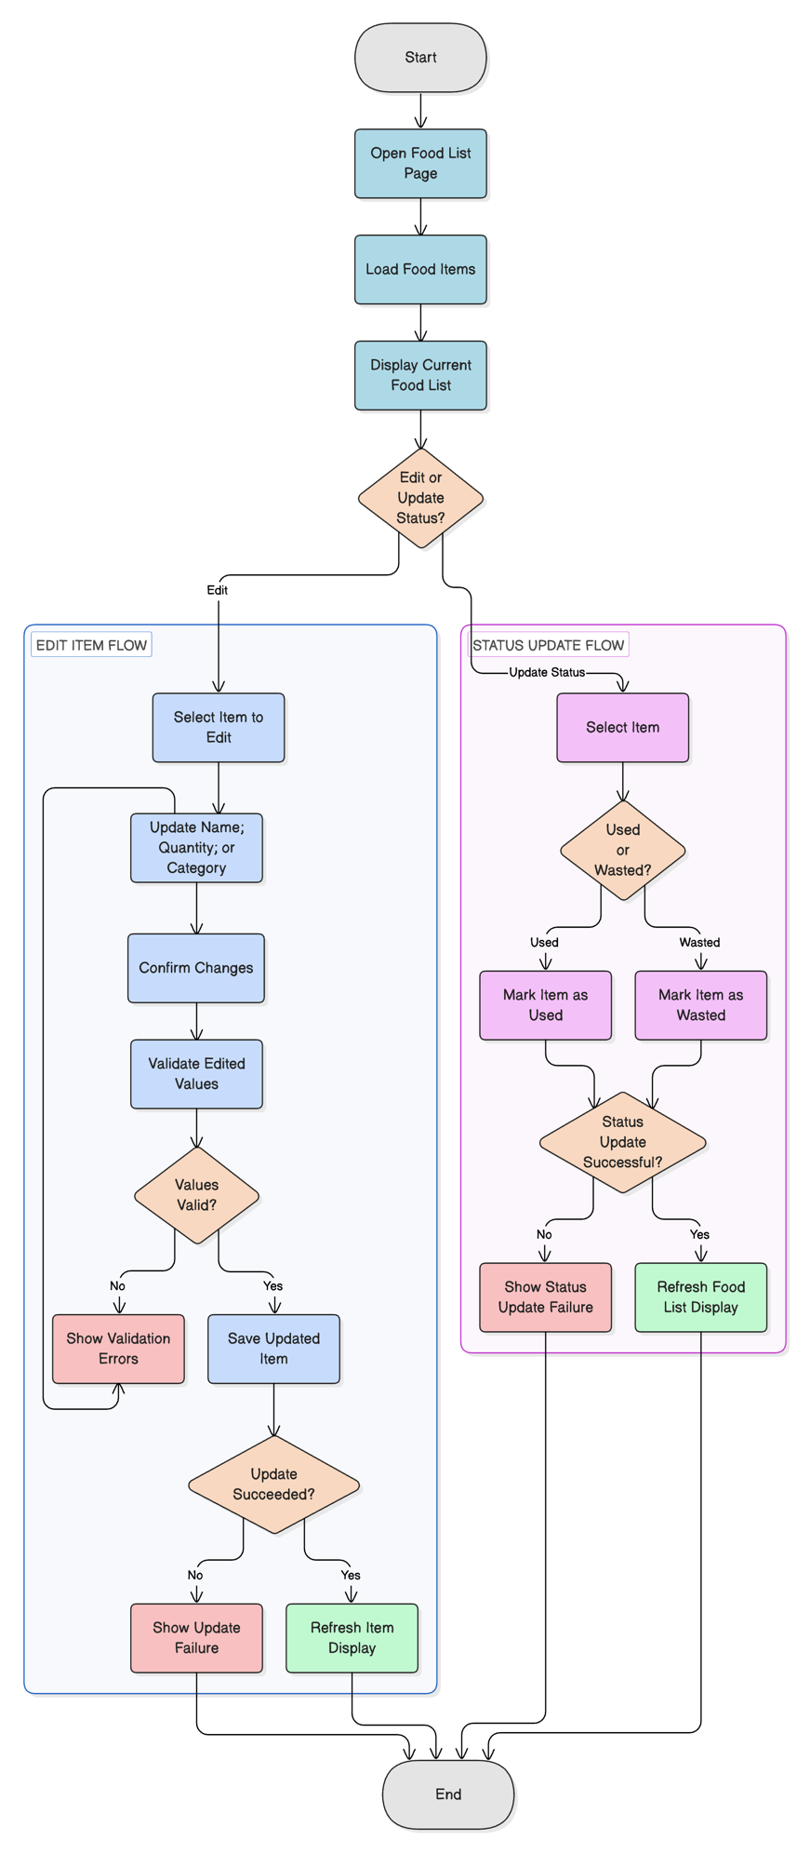
Fig 9: Activity Diagram (Users Food list)

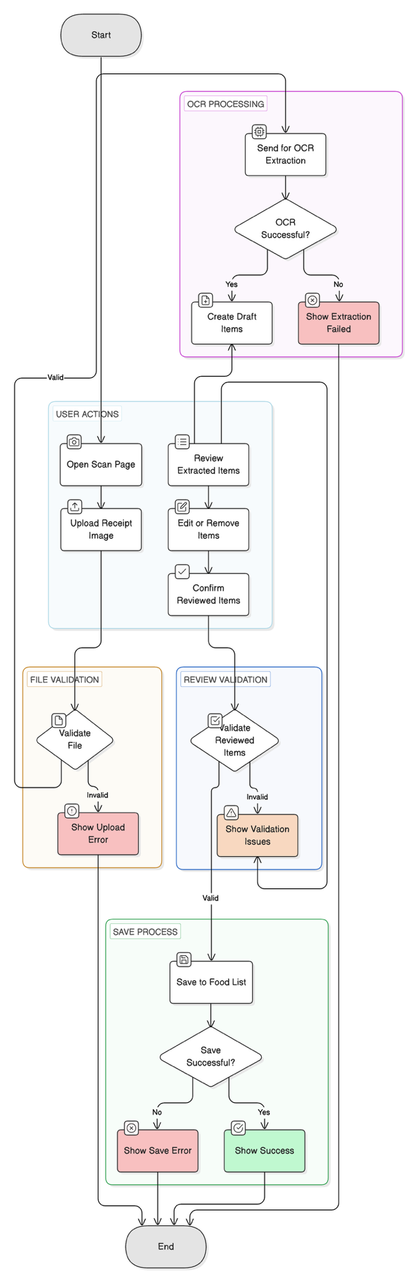
Fig 10: Activity Diagram (Users Scan Receipt)
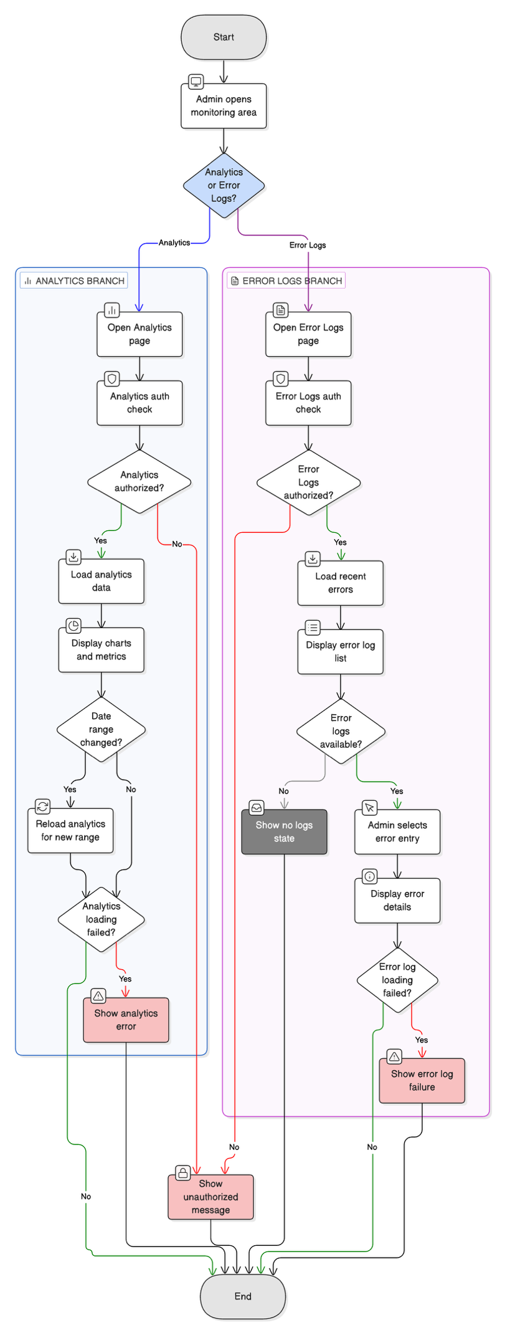
Fig 11: Activity Diagram (Analytics and Error logs)

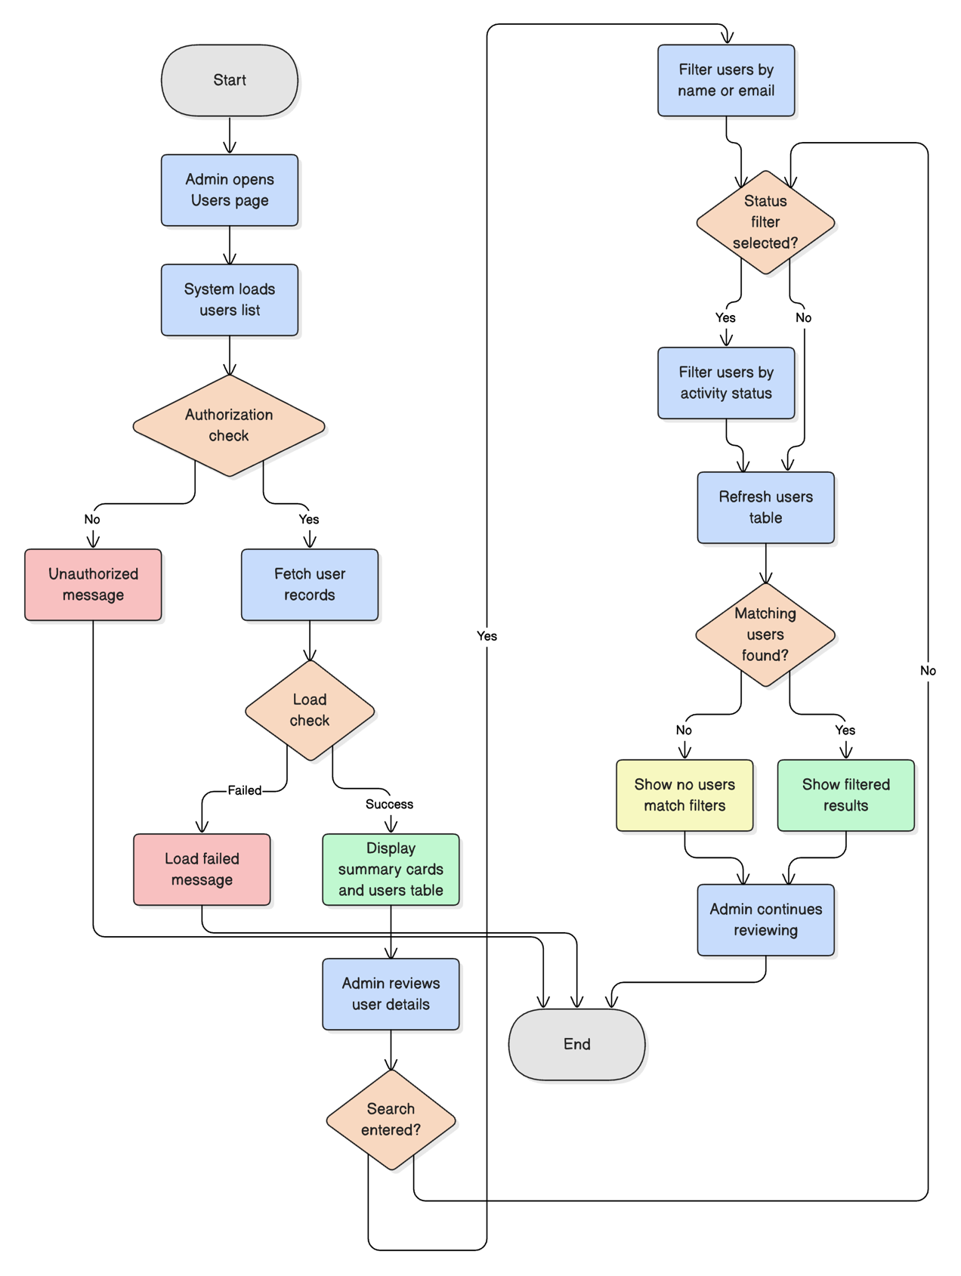
Fig 12: Activity Diagram (Admin Users List)

A8. Sequence Diagram
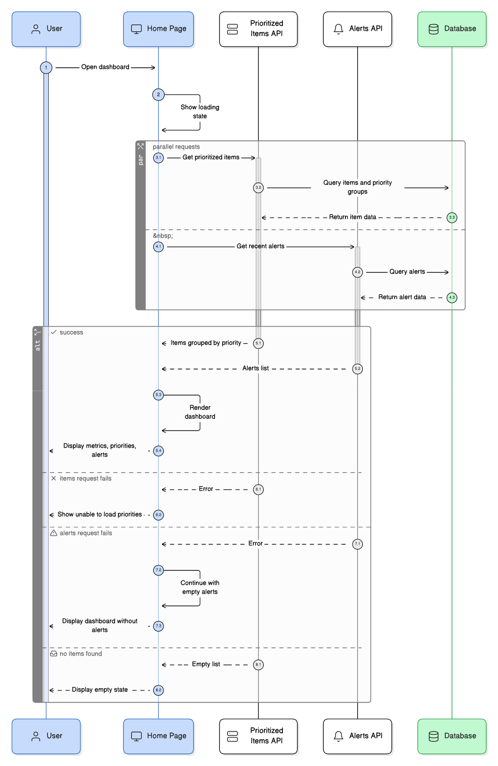
Fig 13: Sequence Diagram (User dashboard)
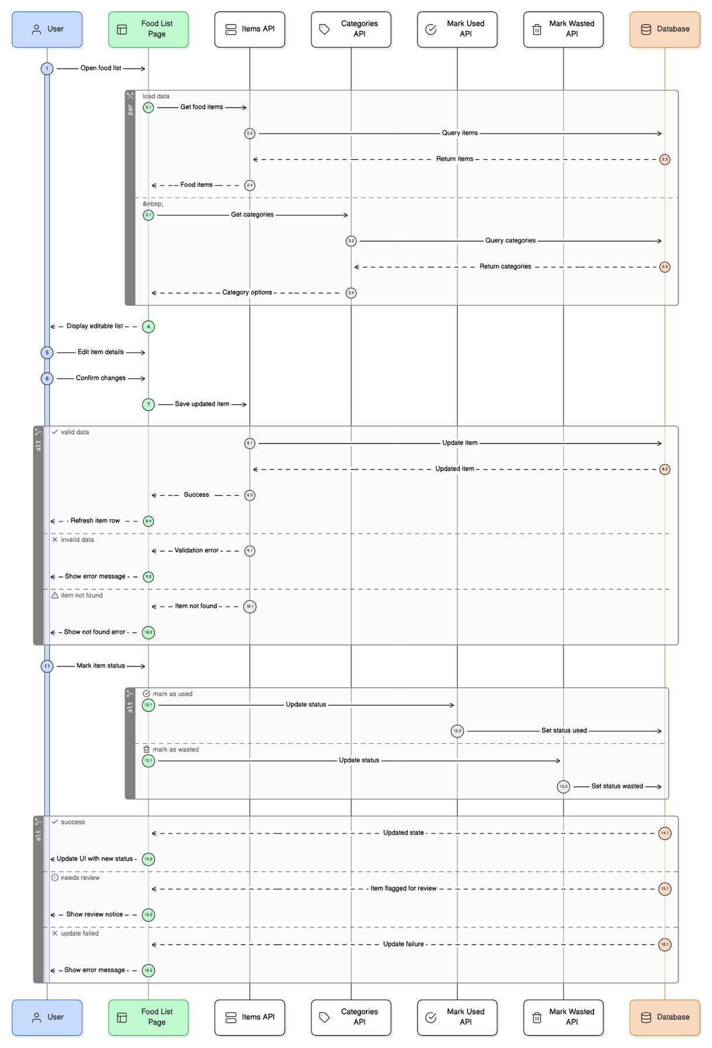
Fig 14: Sequence Diagram (User food list)
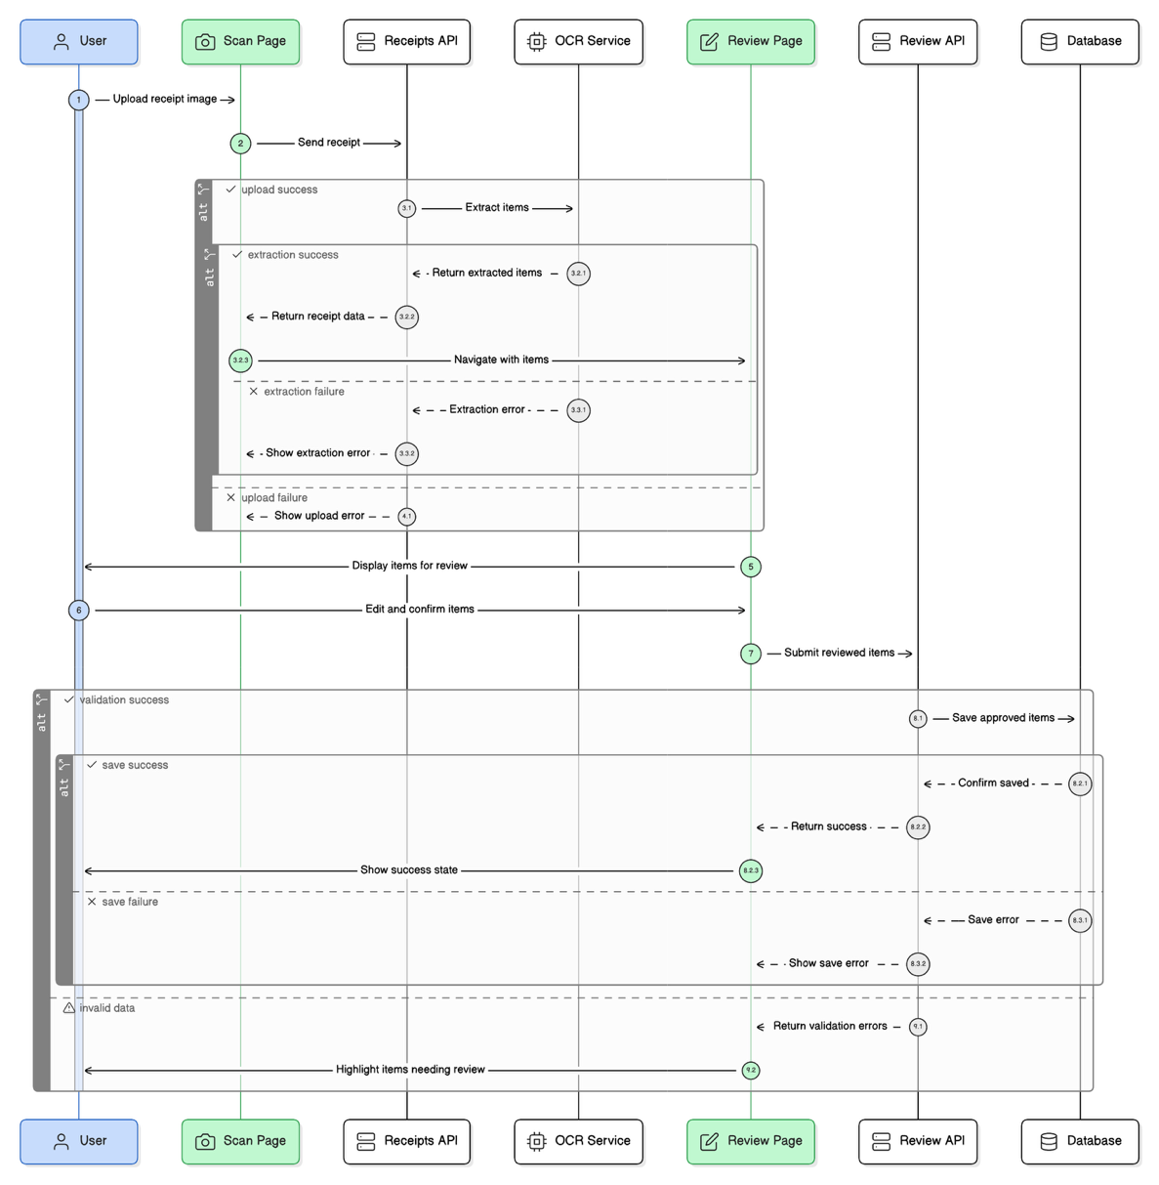
Fig 15: Sequence Diagram (User scan receipt)

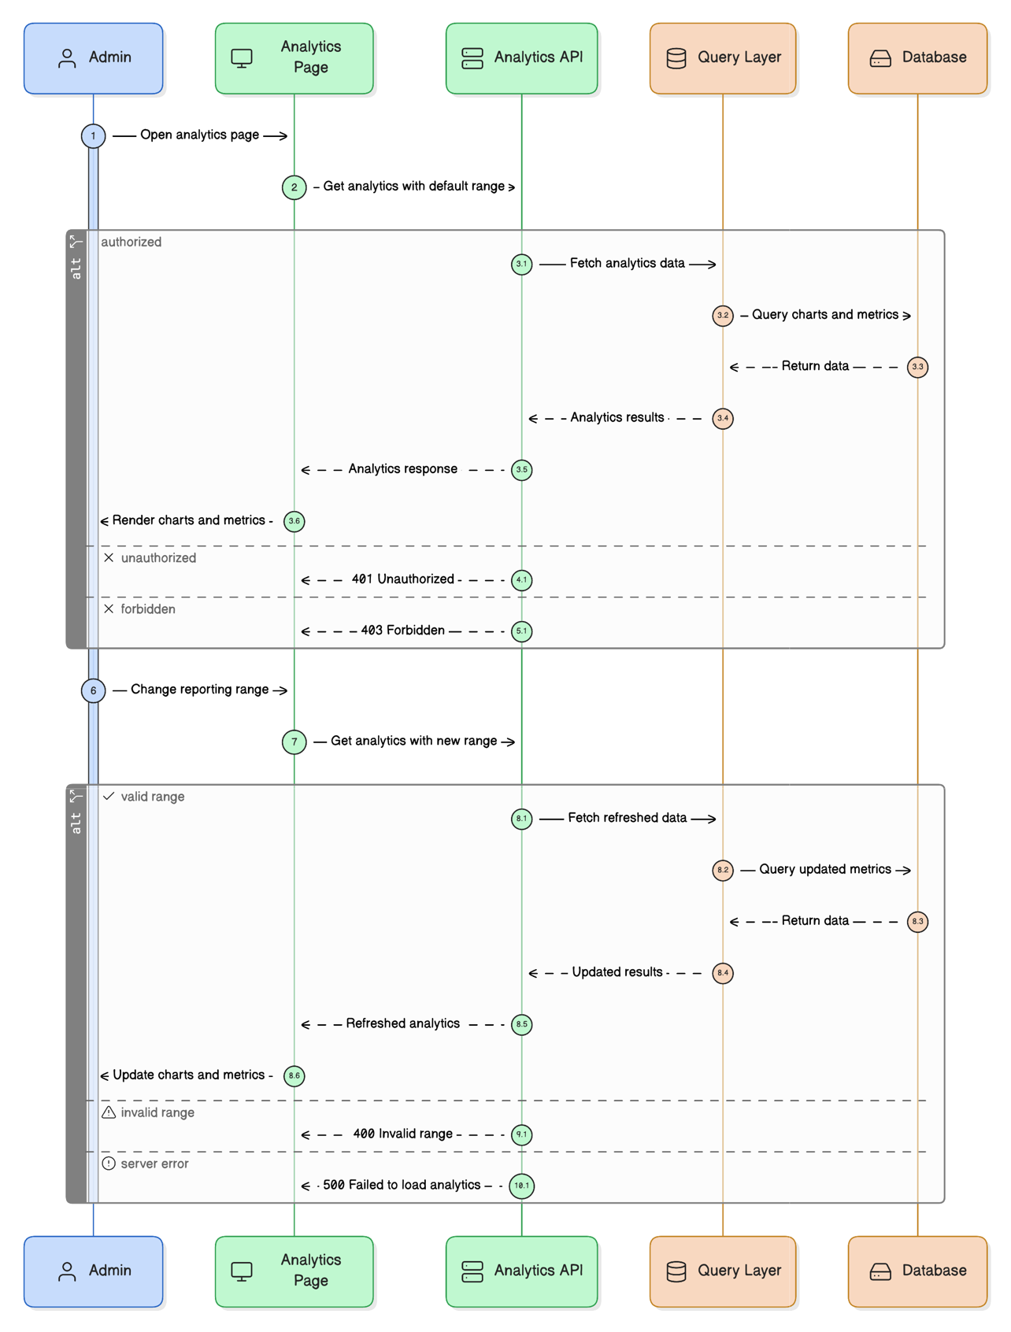
Fig 16: Sequence Diagram (Admin analytics)
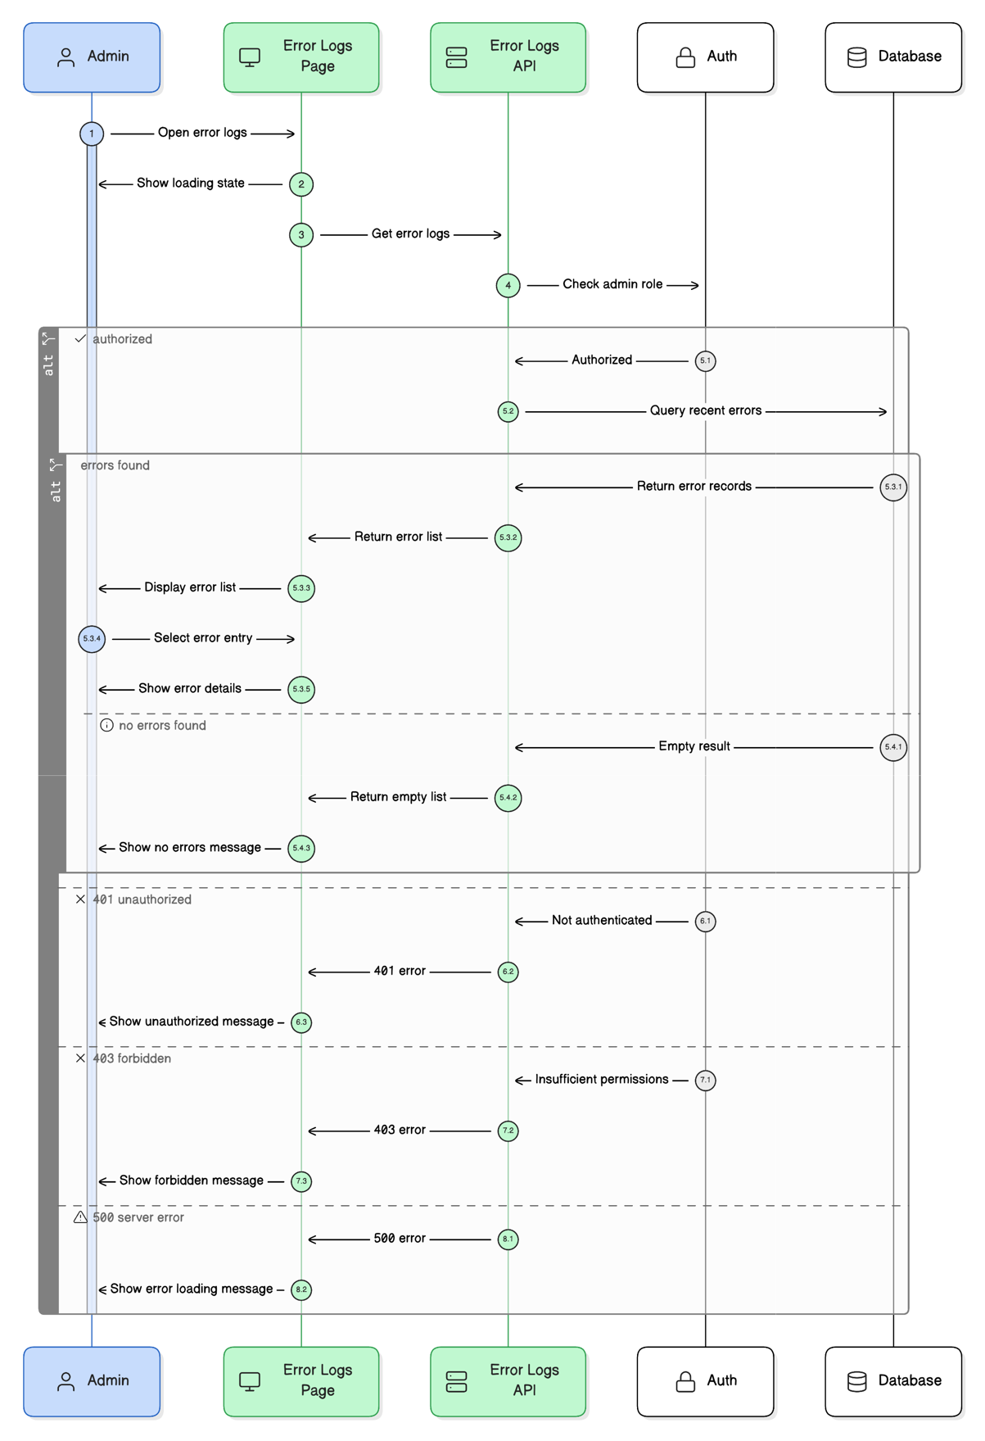
Fig 17: Sequence Diagram (Admin error logs)
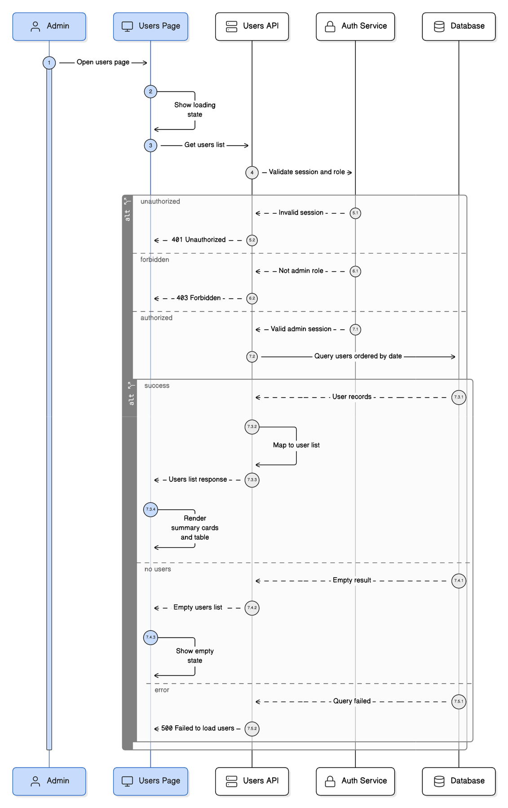
Fig 18: Sequence Diagram (Admin users list)

A9. ERD Diagram
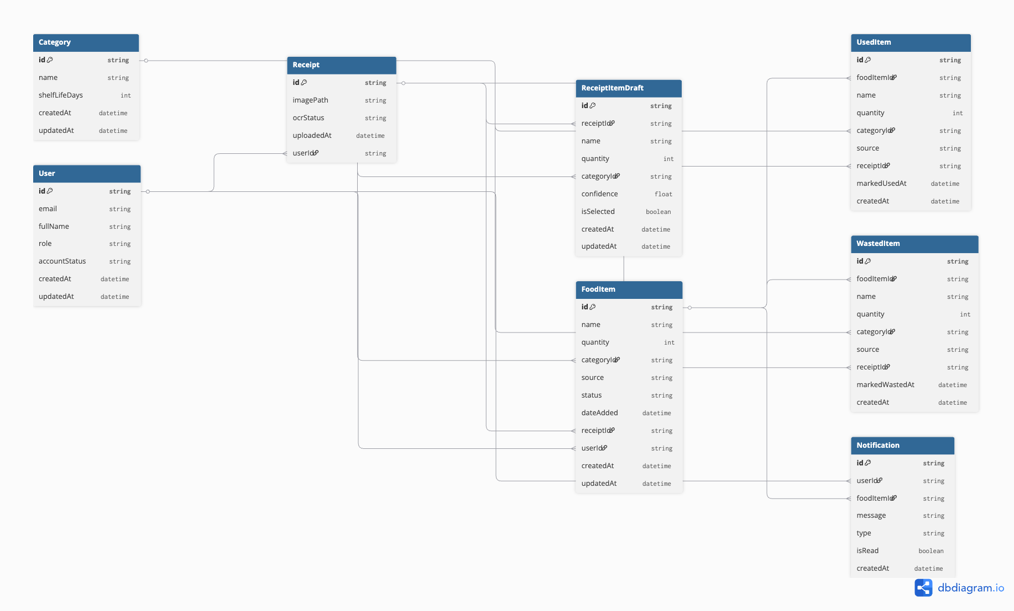
Fig 19: ERD Diagram

A10. Paper Prototype of Fresh Trace
As an Active/Occasional user, I want to see which food items should be used first so that I can decide what to cook or eat next (&) As an Active/Occasional user, I want to view the lifespan status of food items so that I can understand how long they have been stored.
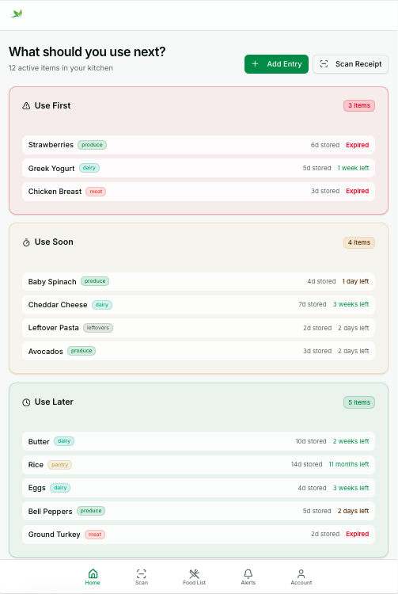
Fig 20: Paper Prototype 1
As an Active/Occasional user, I want to receive notifications so that I can stay informed about expiring items.
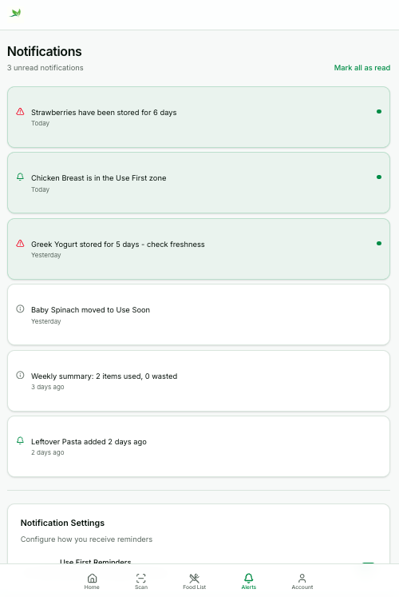
Fig 21: Paper Prototype 2
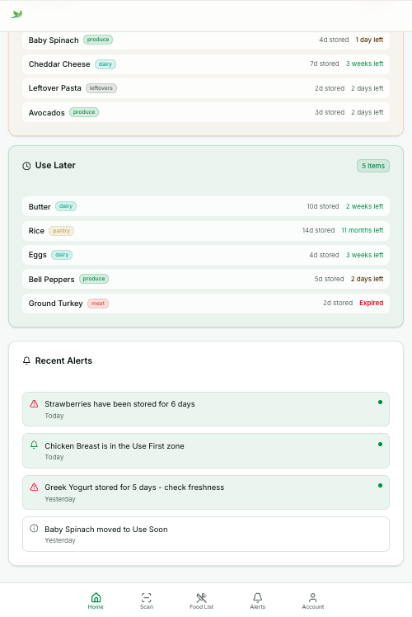
Fig 22: Paper Prototype 3
As an Active or Occasional user, I want to capture or upload a grocery receipt so that I do not have to enter each item manually.
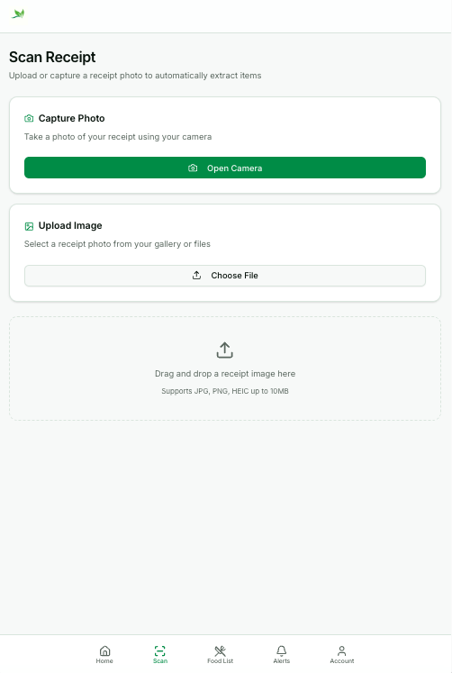
Fig 23: Paper Prototype 4
As an Active/Occasional user, I want to review items detected from the scanned receipt so that only the correct items are saved. (&) As an Active/Occasional user, I want to add and remove the items extracted from the scanned receipt so that I can remove incorrect items and add missed items. (&) As an Active/Occasional user, I want to edit the items extracted so that I can make changes to details of item such as name, category, and quantity. (&) As an Active/Occasional user, I want to save confirmed items so that they appear in my food list.
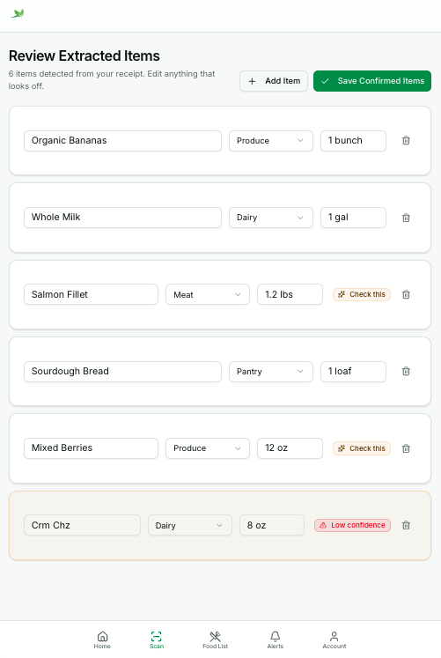
Fig 24: Paper Prototype 5

As an Active or Occasional user, I want to add items manually so that I can still have items that are not on a receipt. (&) As an Active or Occasional user, I want to select a category so that items added are organized.
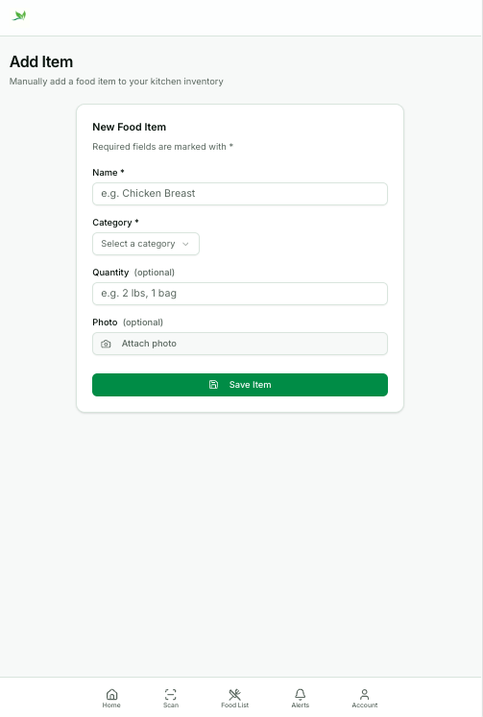
Fig 25: Paper Prototype 6

As an Active or Occasional user, I want to edit food items on the list so that I can make changes and keep it updated. (&) As an Active or Occasional user, I want to mark an item I have used so that I know I no longer have it. (&) As an Active or Occasional user, I want to mark an item that was wasted so that I can accurately track what was not used. (&) As an Active/Occasional user, I want to view the lifespan status of food items so that I can understand how long they have been stored.
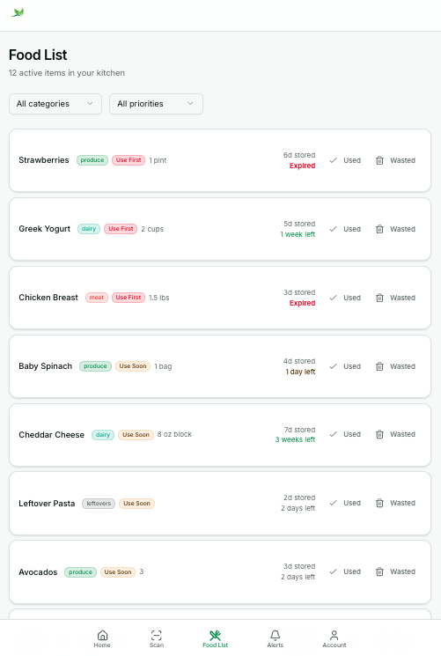
Fig 26: Paper Prototype 7
As an Admin, I want to access a system overview so that I can monitor activity across the systems.
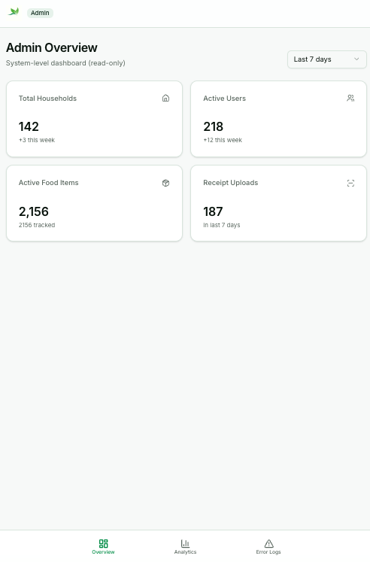
Fig 27: Paper Prototype 8
As an admin, I want to view analytics and reports so that I can monitor system usage and maintain accurate documentation.
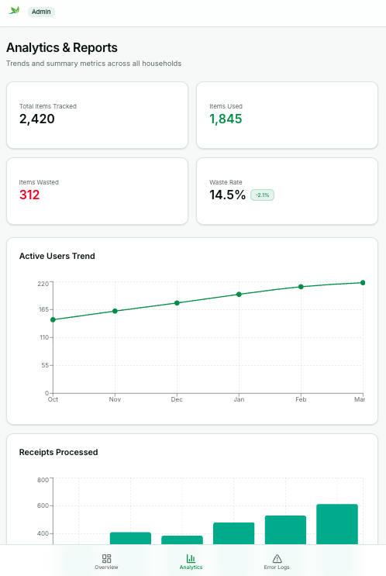
Fig 28: Paper Prototype 9
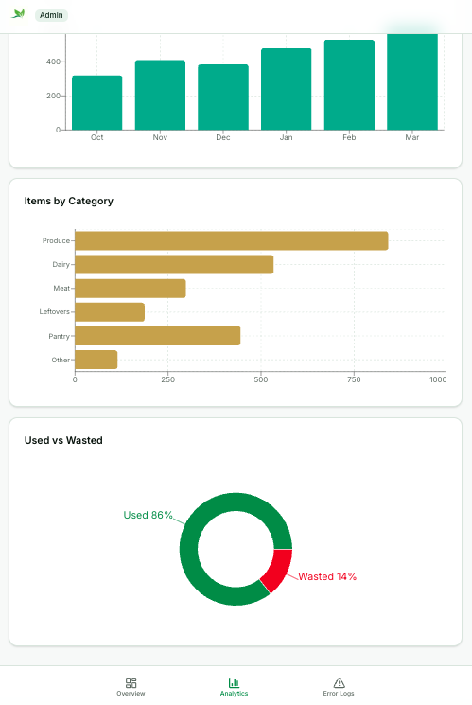
Fig 29: Paper Prototype 10
As an admin, I want to access system error logs so that I can identify and investigate issues with the system.
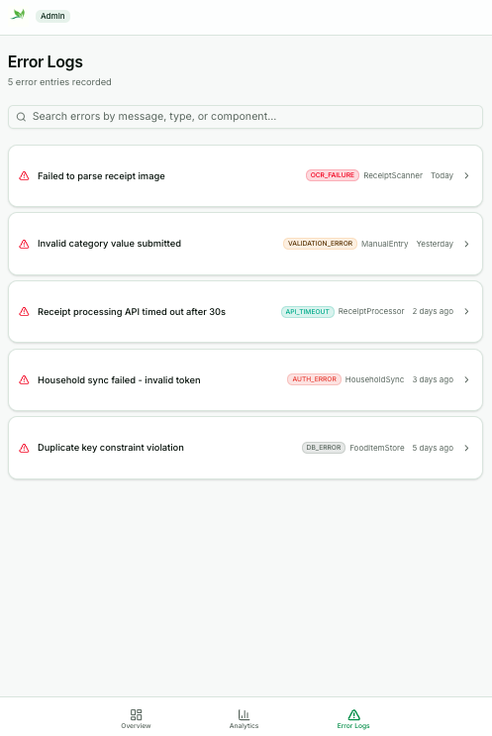
Fig 30: Paper Prototype 11

